Task 2 Project Report
Book Migration API using Spring Boot, MySQL and Flyway
InternSpark AICTE-listed Java Internship
Developed by: Shashank Kumar

1. Introduction
Book Migration API is a Spring Boot based RESTful application developed to demonstrate relational database integration using MySQL together with Spring Data JPA and Flyway database migrations. The project follows a layered architecture consisting of Controller, Service, Repository and Entity layers. Flyway is used to maintain version-controlled database schema changes while Spring Data JPA simplifies database access through repositories.

2. Objectives
- Integrate a Spring Boot application with MySQL.
- Demonstrate Object Relational Mapping using Spring Data JPA.
- Manage database schema evolution using Flyway.
- Seed sample records automatically.
- Implement CRUD REST APIs for book management.
- Test endpoints using Postman.

3. Technologies Used
- Java 17
- Spring Boot 3
- Spring Data JPA
- MySQL
- Flyway
- Maven
- Lombok
- IntelliJ IDEA
- Postman.

📂 Project Structure
book-migration-api
│
├── src
│ ├── main
│ │ ├── java
│ │ │ └── com.shashank.bookmigrationapi
│ │ │ ├── controller
│ │ │ │ └── BookController.java
│ │ │ │
│ │ │ ├── entity
│ │ │ │ └── Book.java
│ │ │ │
│ │ │ ├── repository
│ │ │ │ └── BookRepository.java
│ │ │ │
│ │ │ ├── service
│ │ │ │ └── BookService.java
│ │ │ │
│ │ │ └── BookMigrationApiApplication.java
│ │ │
│ │ └── resources
│ │ ├── application.properties
│ │ └── db
│ │ └── migration
│ │ ├── V1__create_books_table.sql
│ │ ├── V2__insert_sample_books.sql
│ │ ├── V3__add_author_column.sql
│ │ └── V4__add_price_column.sql
│
├── pom.xml
├── README.md
└── screenshots

4. System Architecture
The application follows a layered architecture. Client requests are handled by BookController, business logic resides in BookService, database operations are performed by BookRepository, and the Book entity maps Java objects to the books table. Flyway executes SQL migration scripts automatically during application startup.

4.5 Project Screenshots

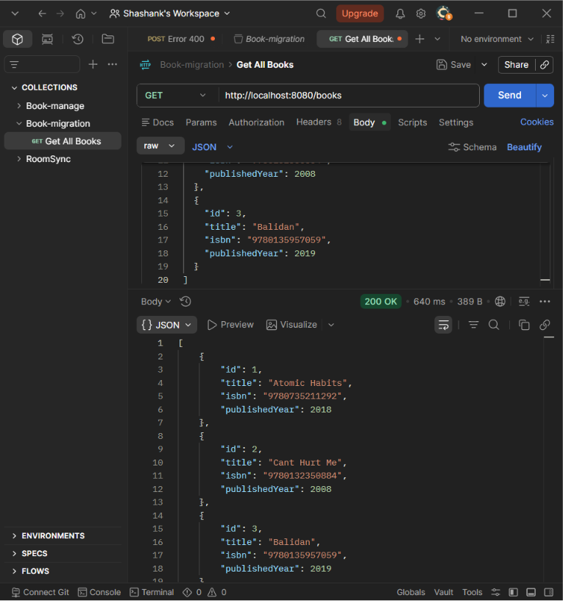
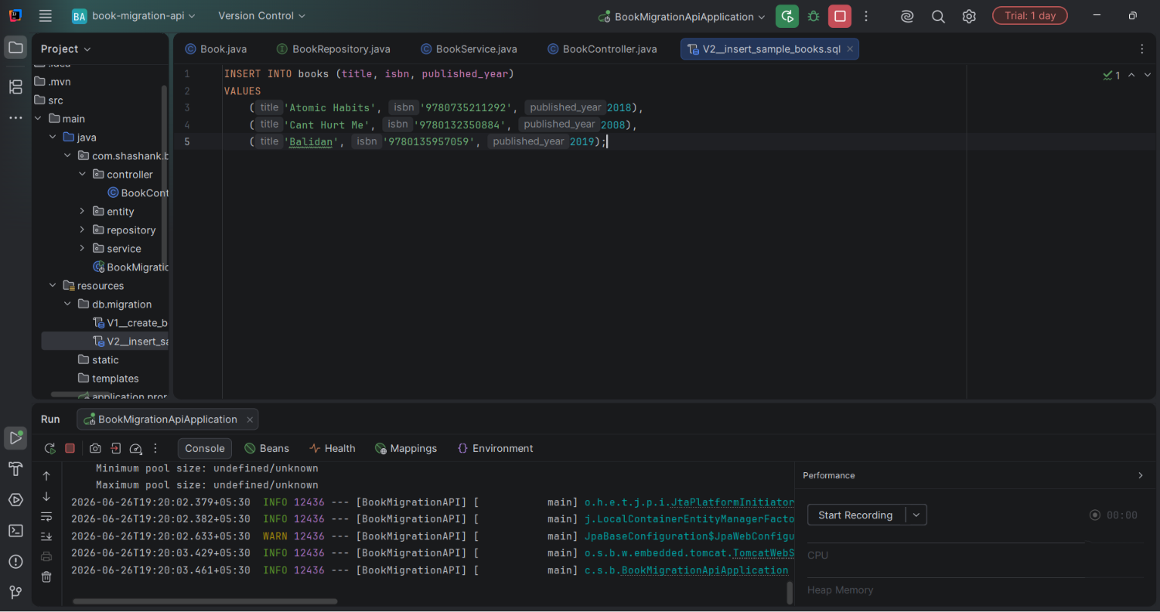
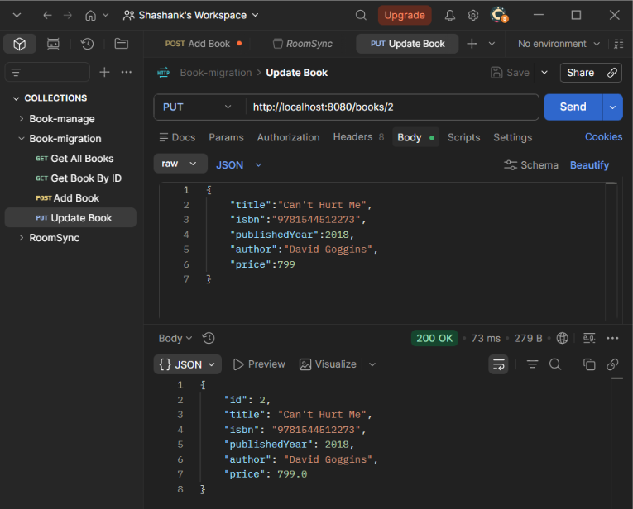
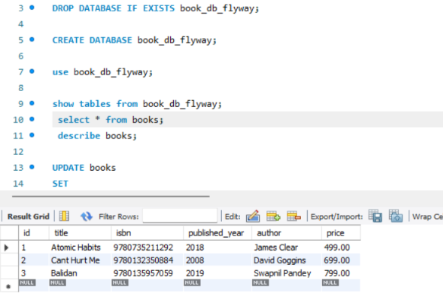
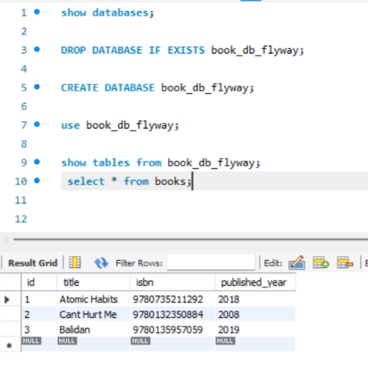

5. Database Design and Flyway
The books table initially contained id, title, isbn and published_year. Migration V2 inserted sample records. Migration V3 introduced the author column and Migration V4 introduced the price column. Flyway maintains the flyway_schema_history table to ensure each migration is executed exactly once.

6. REST API Implementation
Implemented endpoints:
GET /books - Retrieve all books
GET /books/{id} - Retrieve book by ID
POST /books - Add a new book
PUT /books/{id} - Update an existing book
DELETE /books/{id} - Delete a book

7. Project Workflow
1. Configure MySQL connection.
2. Create migration scripts.
3. Flyway creates and updates schema.
4. Spring Data JPA maps entities.
5. Repository accesses database.
6. Service processes business logic.
7. Controller exposes REST APIs.
8. APIs are tested using Postman.

8. Testing and Results
The project was successfully executed. Flyway created the database schema and maintained migration history. Sample data was inserted automatically and CRUD operations were verified through Postman. The API returned JSON responses and reflected changes in the MySQL database.

9. Features
- Layered Architecture
- RESTful CRUD APIs
- MySQL Integration
- Spring Data JPA
- Flyway Database Versioning
- Automatic Schema Migration
- Sample Data Seeding
- Version Controlled Database Changes

10. Conclusion

The project successfully demonstrates modern backend development practices by combining Spring Boot, MySQL, Spring Data JPA and Flyway. It highlights automated database version control, maintainable architecture and RESTful API development. The implementation can be further enhanced by adding validation, authentication, exception handling, pagination and unit testing.

